

**Computer & Electronic Engineering**

**Final Year Project "Music Host Interface"**

**Sprint 4: Week 2 Log**

**Thomas Flynn**

**Project Supervisor: Brian O'Shea**

**24/01/16**

# 1 Log Entries

## 1.1.0 Entry 1: 23/01/16

I move code from screen 2 constructor to "initialize()". I also created MySQL database for testing as well as Copy song file to blob on MySQL. I move code from screen 2 constructor to "initialize()".

I also created MySQL database for testing as well as copy song file to blob on MySQL

I Started database GUI elements

# 2 Research done:

Controller initialization interface

Called to initialize a controller after its root element has been completely processed.

**Parameters:**

location - The location used to resolve relative paths for the root object, or null if the location is not known.

resources - The resources used to localize the root object, or null if the root object was not localized.

# 3 Problems encountered:

3.1 Loading screen2.fxml

There seems to be a problem with loading the "screen2.fxml" when I try to open it from intelliJ. The solution seems to be to create a copy of the file and then open it. This is only really a problem when I'm tweaking the layout of the GUI or adding new components. Otherwise I can edit the fxml code directly in IntelliJ.

## 3.2 MysqlDataTruncation

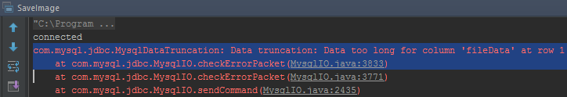

## 3.3 packetTooBigException:

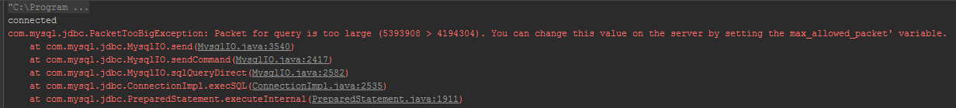

## 3.4 Solution to problem:

**ALTER** **TABLE** localsongdatabase **MODIFY** fileData **LONGBLOB**;

## 3.4.1 Code update:

**CREATE** **TABLE** localSongDatabase

(

songID **int** ,

songName **varchar**(50) ,

artistName **varchar**(50) ,

fileData **varbinary**(8000)

);localsong

# 4 GIT Repositories:

## 4.1 FYP-GUI

4.1.1 commits: #24 **"**Move code from screen 2 constructor to initialize()"

# 5 Tasks completed:

Move code from screen 2 constructor to "initialize()"

create MySQL database for testing

Copy song file to blob on MySQL

Started database GUI elements

# 6 Trello boards

## 6.1 Board at the start of the week:

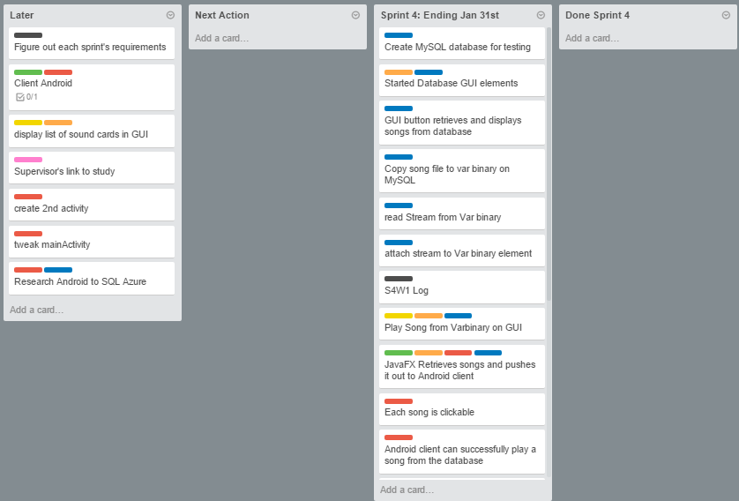

# 6.2 Board at the end of the week:

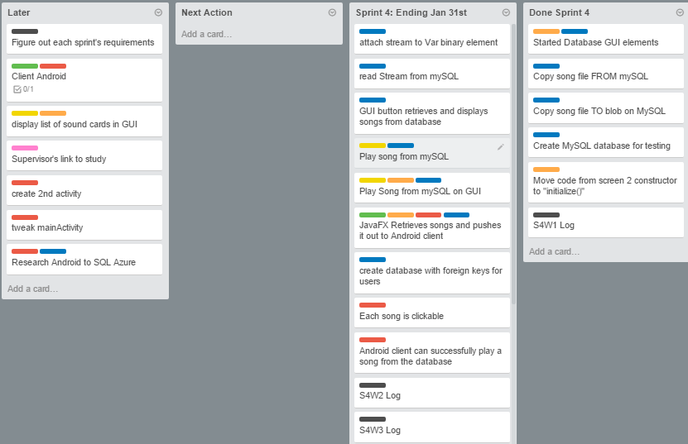

# 7 Toggl Time Logs

## 7.1 Weekly time Log bar chart:

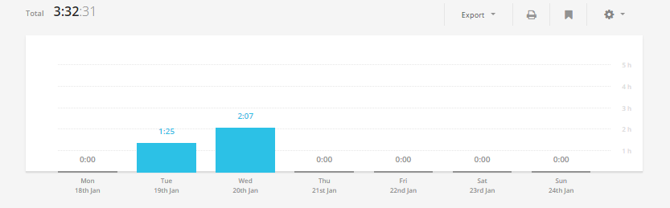

## 7.2 Weekly Time Log:

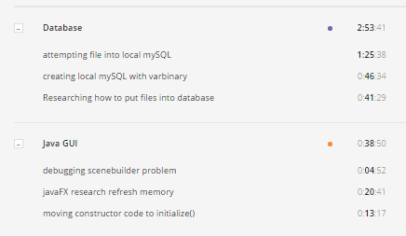

## 7.3 Weekly log Pie Charts:

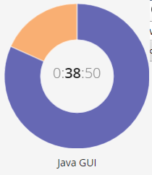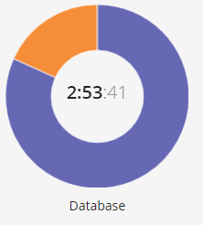

# 8 Link References:

## 8.1 javafx research:

https://docs.oracle.com/javafx/2/api/javafx/fxml/Initializable.html